IBM z/OS Connect EE V3.0
Developing RESTful APIs

for a CICS COMMAREA program

Table of Contents
Overview 3
Connect the IBM z/OS Explorer to the z/OS Connect EE Server 4
z/OS Connect EE APIs and a CICS COMMAREA program 7
Create the services 7
Export and deploy the Service Archive files 19
Create the API Project 21
Compose the API with a CICS COMMAREA application 24
Deploy the API to a z/OS Connect EE Server 31
Test the API 34
Optional 43

Important: On the desktop there is a file named Developing APIs CopyPaste.txt. This file contains commands and other text used in this workshop. Locate that file and open it. Use the copy-and-paste function (Ctrl-C and Ctrl-V) to enter commands or text. It will save time and help avoid typo errors. As a reminder text that appears in this file will be highlighted in yellow.

Overview
Important – You do not need any skills with CICS to perform this exercise. Even if CICS is not relevant to your current plans performing this exercise will give additional experience using the Toolkit to develop services and APIs.

The objective of these exercises is to gain experience with working with z/OS Connect EE and the API Toolkit. These two products allow the exposure of z/OS resources to JSON clients. More in-depth information about the customization of z/OS Connect EE, z/OS Connect EE security, the use of the API Toolkit and other topics is provided by the 1 day ZCONNEE – z/OS Connect Workshop. For information about scheduling this workshop in your area contact your IBM representative.

If you have completed another of the developing APIs exercises for this workshop you can start with section z/OS Connect EE APIs and a CICS COMMAREA program on page 9.

General Exercise Information and Guidelines

- This exercise requires using z/OS user identity USER1. The password for this user will be provided by the lab instructor.

- Any time you have any questions about the use of IBM z/OS Explorer, 3270 screens, features or tools do not hesitate to ask the instructor for assistance.

- Text in bold and highlighted in yellow in this document should be available for copying and pasting in a file named Development APIs CopyPaste file on the desktop.

Connect the IBM z/OS Explorer to the z/OS Connect EE Server

Begin by establishing a connection to your z/OS Connect server from IBM z/OS Explorer. If you have performed one of the other exercises in this series of exercises this step may not be required.

- On the workstation desktop, locate the z/OS Explorer icon and double click on it to open the Explorer.
- You will be prompted for a workspace:
- Tech-Tip: Windows desktop tools can be opened either by double clicking the icon or by selecting the icon and right mouse button clicking and then selecting the Open option.
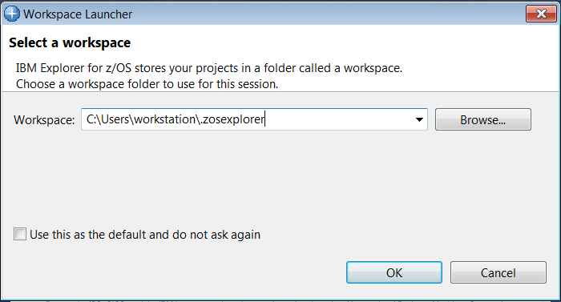

Take the default value by clicking OK.
- The Explorer should open in the z/OS Connect Enterprise Edition perspective. Verify this by looking in the upper left corner. You should see:
N.B. If a Welcome screen is displayed then click the white X beside Welcome to close this view.

- If the current perspective is not z/OS Connect Enterprise Edition, select the Open Perspective icon on the top right side to display the list of available perspectives, see below. Select z/OS Connect Enterprise Edition and click the OK button to switch to this perspective.
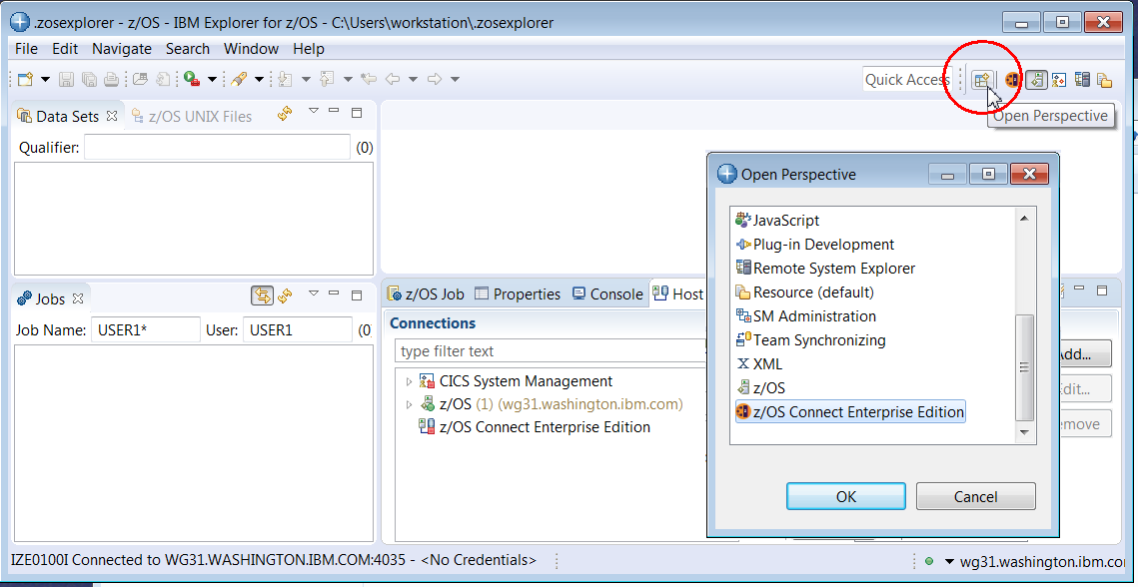

- To add a connection to the z/OS Connect Server select z/OS Connect Enterprise Edition connection in the Host connections tab in the lower view and then click the Add button.
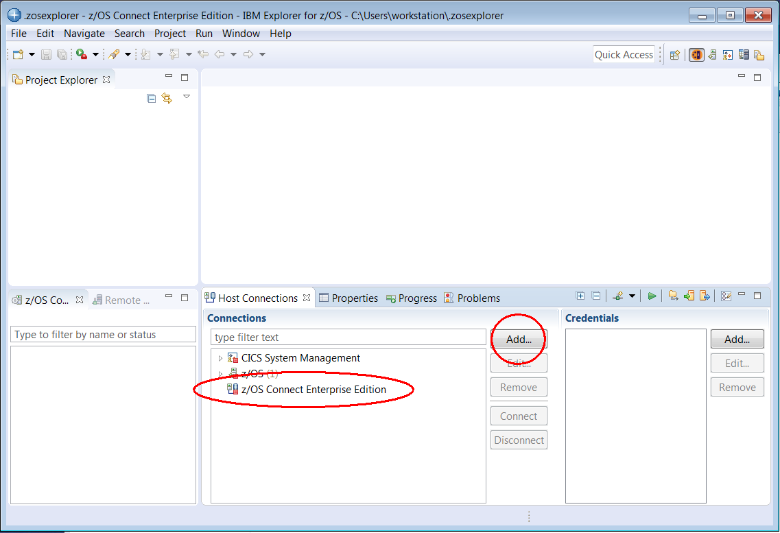

- In the pop-up list displayed select z/OS Connect Enterprise Edition and on the Add z/OS Connect Enterprise Edition Connection screen enter wg31.washington.ibm.com for the Host name, 9453 for the Port Number, check the box for Secure connection (TLS/SSL) and then click the Save and Connect button.
Tech-Tip: Eclipse based development tools like z/OS Explorer; provide a graphical interface consisting of multiple views within a single window.

A view is an area in the window dedicated to providing a specific tool or function. For example, in the window above, Host Connections and Project Explorer are views that use different areas of the window for displaying information. At bottom on the right there is a single area for displaying the contents of four views stacked together (commonly called a stacked views), z/OS Host Connections, Properties, Progress and Problems. In a stacked view, the contents of each view can be displayed by clicking on the view tab (the name of the view).

At any time, a specific view can be enlarged to fill the entire window by double clicking in the view’s title bar. Double clicking in the view’s title bar will be restored the original arrangement. If a z/OS Explorer view is closed or otherwise disappears, the original arrangement can be restored by selecting Windows → Reset Perspective in the window’s tool bar.

Eclipse based tools also can display multiple views based on the current role of the user. In this context, a window is known as a perspective. The contents (or views) of a perspective are based on the role the user, i.e., developer or administrator.
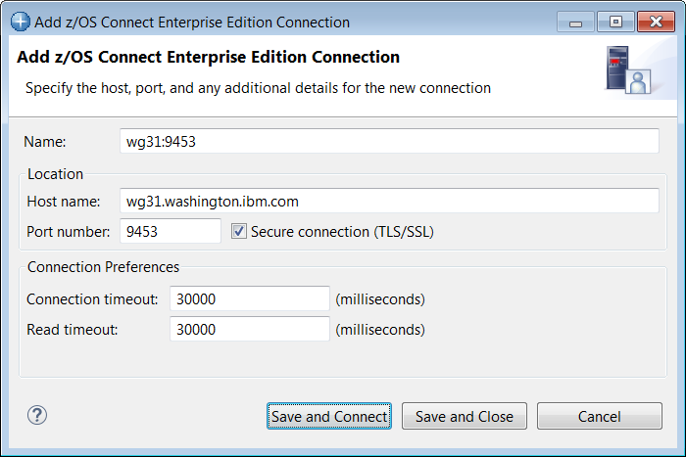

- On the z/OS Connect Enterprise Edition – User ID required screen create new credentials for a User ID of Fred and a Password or Passphrase of fredpwd (case matters). Remember the server is configured to use basic security. If SAF security had been enabled, then a valid RACF User ID and password will have to be used instead. Click OK to continue.
- Click the Accept button on the Server certificate alert – Accept this certificate screen. You may be presented with another prompt for a userid and password, enter Fred and fredpwd again.
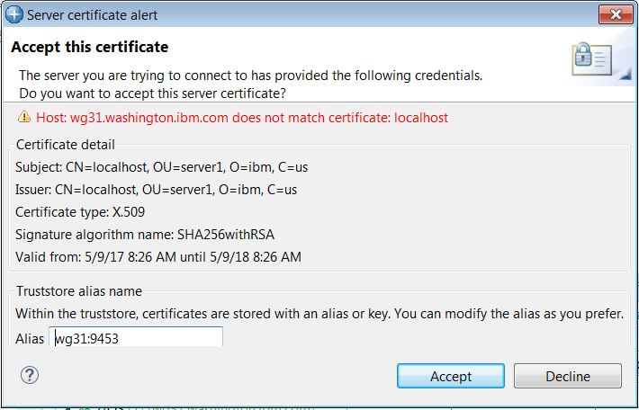

- The status icon beside wg31:9453 should now be a green circle with a lock. This shows that a secure connection has been established between the z/OS Explorer and the z/OS Connect server. A red box indicates that no connection exists.
A connection to the remote z/OS system was previously added. In the Host Connection view expand z/OS Remote System under z/OS and select wg31.washington.ibm.com. If the connection is not active the Connect button will be enabled. Click the Connect button and this will establish a session to the z/OS system. This step is required when submitting job for execution and viewing the output of these jobs later in this exercise

z/OS Connect EE APIs and a CICS COMMAREA program

Create the services
The CICS application that will be invoked by this service is CICS sample application DFH0XCMN. This program is provided with the CICS office supply sample application. DFH0XCMN is passed a COMMAREA which contains a request field. This field is used by DFH0XCMN to determine the next which of 3 functions of the sample application will be accessed. The three functions are (1) inquire on a single item in the catalog (INQS), (2) provide a list of items in the catalog starting with a specific item (INQC) or (3) place an order for an item (ORDR). The COMMAREA is based on a COPYBOOK which uses redefines the COMMAREA based on the type of request.

The next step is to create 3 services which correspond to these three functions provided by the sample program DFH0XCMN. These service names must match the service names specified in the server.xml file (see catalog.xml on page 36).

- In the z/OS Explorer session switch the perspective back to the z/OS Connect Enterprise Edition perspective.

- In the upper left, position your mouse anywhere in the Project Explorer view and right-mouse click, then select New →Project:
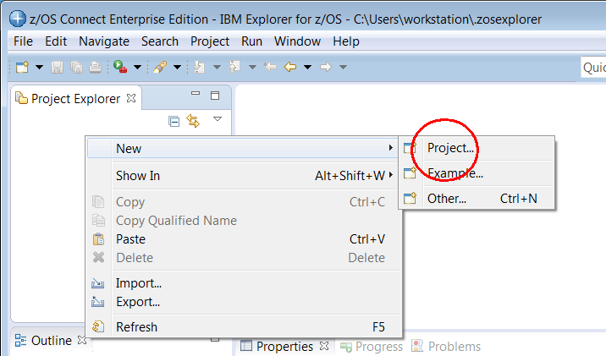

- In the New Project window, scroll down and open the z/OS Connect Enterprise Edition folder and select z/OS Connect EE Service Project and then click the Next button.
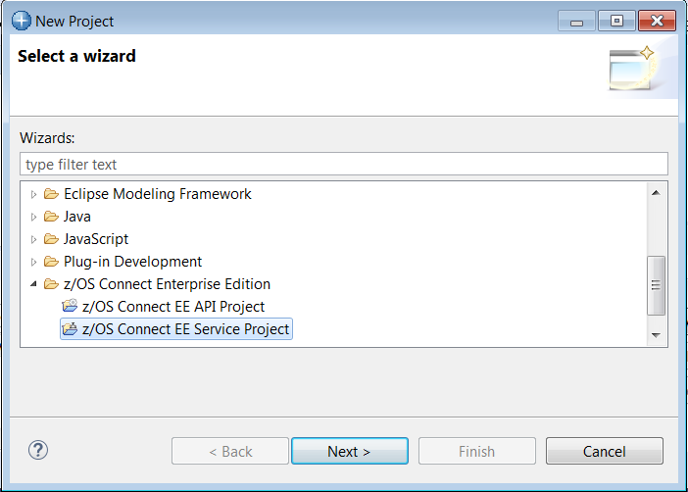

- On the new New Project window enter inquireSingle as the Project name and use the pull-down arrow to select CICS COMMAREA Service as the Project type. Click Finish to continue
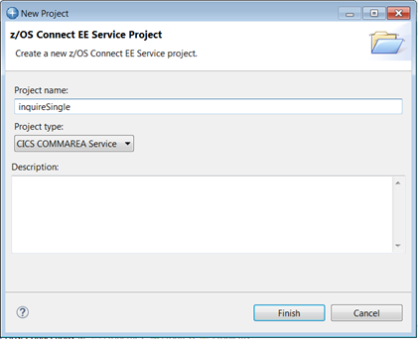

- This will open the Overview window for the inquireSingle Service. For now disregard the message about the 3 errors detected, they will be addressed shortly.
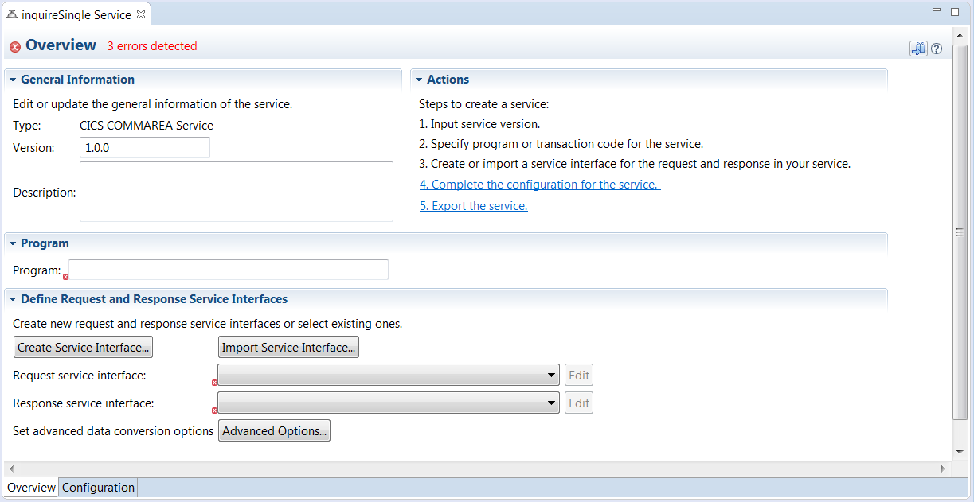
- Next enter the target CICS program name DFH0XCMN in the area beside Program (case is important).
- Click the Create Service Interface button to create the first service required by this API and enter a Service interface name of inquireSingleRequest. Click OK to continue.
- This will open a Service Interface Definition window.
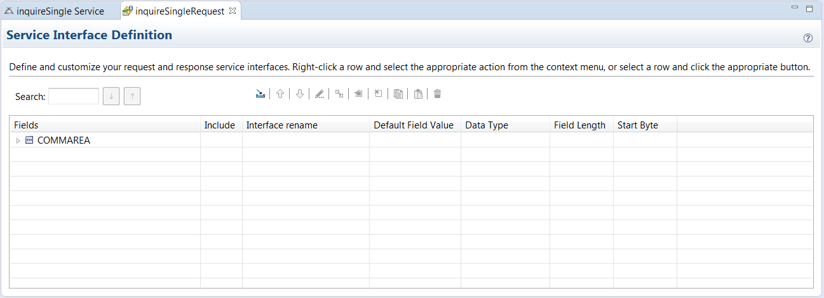
- The first step is to import the COBOL copy book that represents the COMMAREA when inquiring on a single item in the Catalog application. This copy book was downloaded from member DFH0XCP1 in the CICS SDFHSAMP target data set.
* Catalogue COMMAREA structure
03 CA-REQUEST-ID PIC X(6).
03 CA-RETURN-CODE PIC 9(2).
03 CA-RESPONSE-MESSAGE PIC X(79).
03 CA-REQUEST-SPECIFIC PIC X(911).
* Fields used in Inquire Catalog
03 CA-INQUIRE-REQUEST REDEFINES CA-REQUEST-SPECIFIC.
05 CA-LIST-START-REF PIC 9(4).
05 CA-LAST-ITEM-REF PIC 9(4).
05 CA-ITEM-COUNT PIC 9(3).
05 CA-INQUIRY-RESPONSE-DATA PIC X(900).
05 CA-CAT-ITEM REDEFINES CA-INQUIRY-RESPONSE-DATA
OCCURS 15 TIMES.
07 CA-ITEM-REF PIC 9(4).
07 CA-DESCRIPTION PIC X(40).
07 CA-DEPARTMENT PIC 9(3).
07 CA-COST PIC X(6).
07 IN-STOCK PIC 9(4).
07 ON-ORDER PIC 9(3).
* Fields used in Inquire Single
03 CA-INQUIRE-SINGLE REDEFINES CA-REQUEST-SPECIFIC.
05 CA-ITEM-REF-REQ PIC 9(4).
05 FILLER PIC 9(4).
05 FILLER PIC 9(3).
05 CA-SINGLE-ITEM.
07 CA-SNGL-ITEM-REF PIC 9(4).
07 CA-SNGL-DESCRIPTION PIC X(40).
07 CA-SNGL-DEPARTMENT PIC 9(3).
07 CA-SNGL-COST PIC X(6).
07 IN-SNGL-STOCK PIC 9(4).
07 ON-SNGL-ORDER PIC 9(3).
05 FILLER PIC X(840).
* Fields used in Place Order
03 CA-ORDER-REQUEST REDEFINES CA-REQUEST-SPECIFIC.
05 CA-USERID PIC X(8).
05 CA-CHARGE-DEPT PIC X(8).
05 CA-ITEM-REF-NUMBER PIC 9(4).
05 CA-QUANTITY-REQ PIC 9(3).
05 FILLER PIC X(888).

- On the Service Interface Definition window there is a tool bar near the top. If you hover over an icon its function will be display as below. Click the Import COBOL or PL/I data structure into the service interface icon to start the import process.
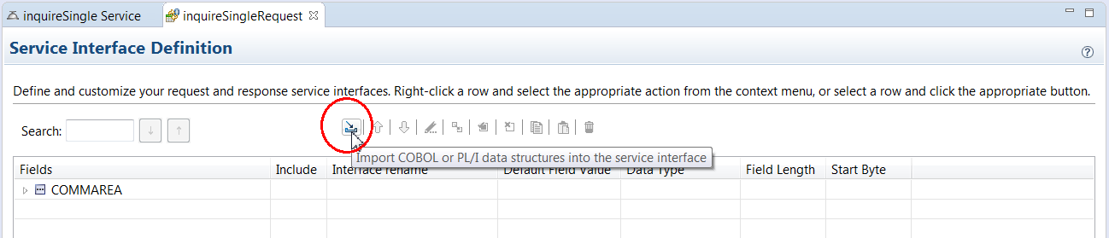

- This will open the Import window. On this window select Local file system as source of the import and COBOL data structure only as the File type. Press the Browse button and Open directory C:\z\CICSLAB and then select file DFH0XCP1.cpy and click Open to import this file into this project. Click the Add to Import List button and the click OK to continue.
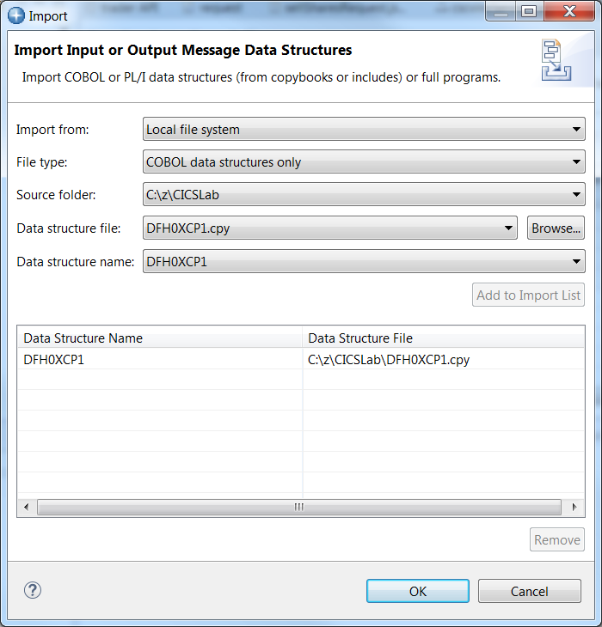

- When you expand COMMAREA you will see the COBOL ‘variables’ that have been imported into the service project. In this service we want to return a single item and the only fields that need to be exposed in the request message is the item number.
  - First uncheck the boxes under Include column so that only CA_INQUIRE_SINGLE and CA_ITEM_REF_REQ are checked. These are the fields that will be exposed to the requestor
of this API.
  - Double click an entry in the Interface rename column to open it for editing. Rename interface fields CA_INQUIRE_SINGLE to inquireSingle and CA_ITEM_REF_REQ to itemID. Change interface field CA_REQUEST_ID by setting its default value to 01INQS.
When finished the Service Interface Definition should look like the below:
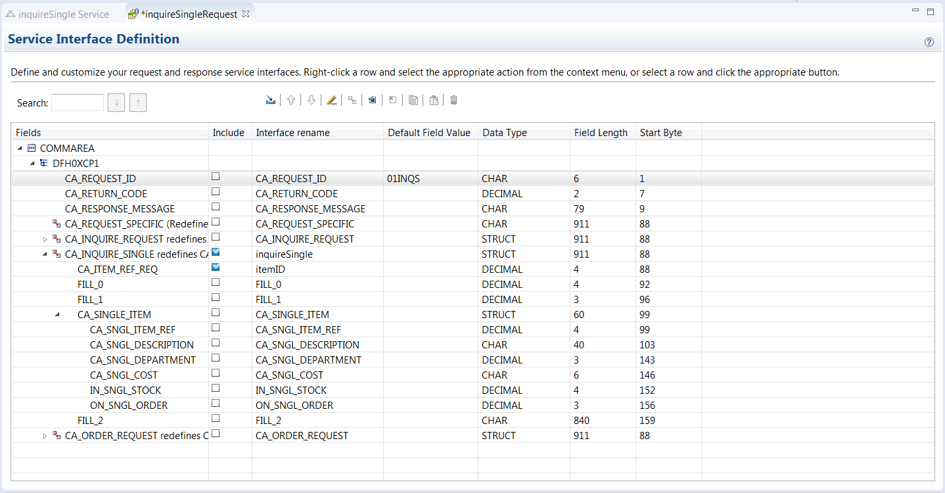
N.B. the original interface names were derived from the COBOL source shown earlier.

- Close the Service Interface Definition window by clicking on the white X in the tab being sure to save the changes. Note now that the Request service interface and the Response service interface areas have now been populated with inquireSingleRequest.si. Also note that you can use their respective Edit buttons to return to the Service Interface Definition window for each interface.
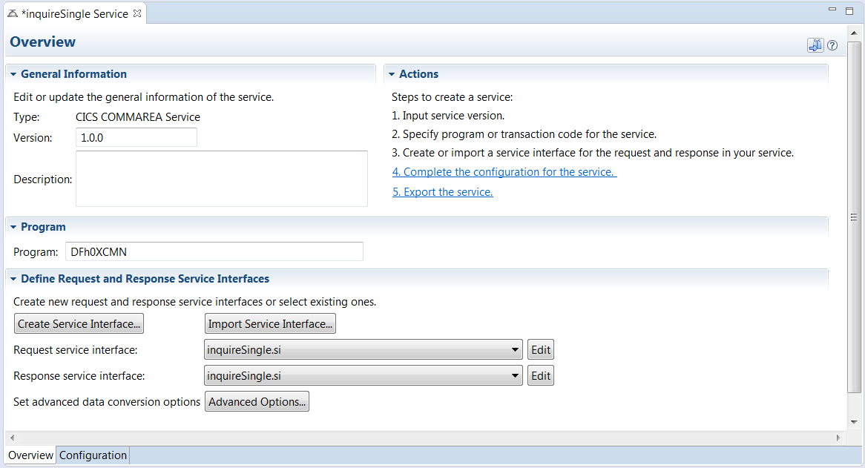
Tech-Tip: Note that even though the program uses a COMMAREA we can easily distinguish which fields are provided in a request and which fields will be in the response by providing different service interfaces. This is particularly useful when using containers.
- Repeat steps 6 through 10 to create a service interface for the inquireSingle service response message. Enter a service interface name of inquireSingleResponse rather than inquireSingleRequest.
- A different set of fields will be returned in the response. Uncheck the boxes under Include column so that only CA_RETURN_CODE, CA_RESPONSE_MESSAGE, CA_INQUIRE_SINGLE and CA_SINGLE_ITEM checked. These are fields that will be exposed to the requestor of this API in the response. You can rename these fields if you choose. If you do some of the later screen shots may be different.
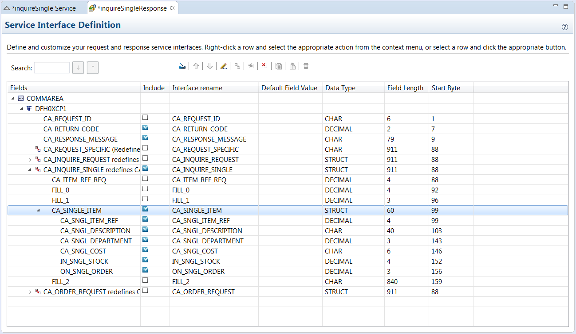

- Close the Service Interface Definition window.
- Set the Response service interface to inquireSingleResponse.si.
- Next, we need to identify a connection reference for which CICS region will be used. Click on the Configuration tab at the bottom of the Overview window to display the Configuration window. Enter catalog in the area beside Connection reference.
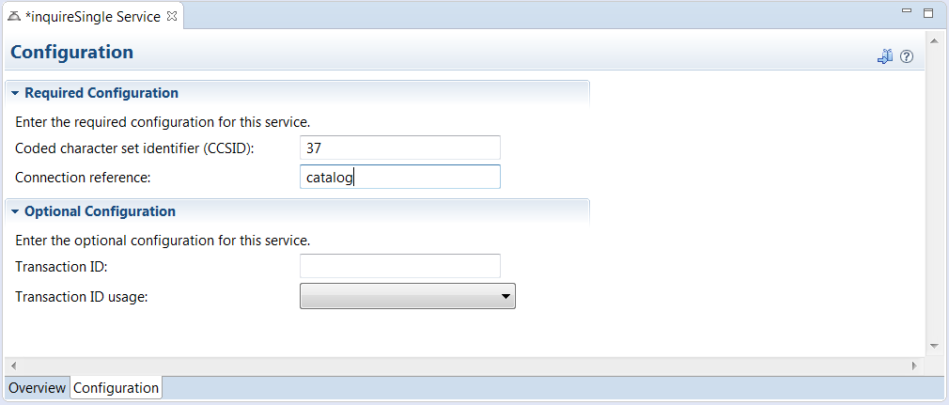

- Tech-Tip: The Connection reference identifies the cicsIpicConnection element to be used to access a CICS region in the z/OS Connect EE configuration, see catalog.xml on page 36.

- Verify that the request and response service interfaces are set correctly. If not, set them as below.
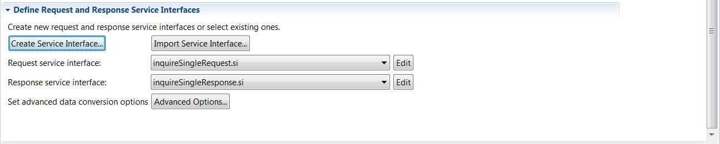

- Save the inquireSingle service by closing all open tabs.
- Repeat steps 1 through 5 to create the inquireCatalog service.
- Repeat steps 6 through 10 to create a service interface for inquireCatalog service request message. Enter a name of inquireCatalogRequest.
- Expand the COMMAREA and perform the following steps for the inquireCatalog request:
- First uncheck the boxes under Include column so that only CA_INQUIRE_REQUEST and CA_LIST_START_REF are checked. These are the fields that will be exposed to the requestor of this API.
- Double click an entry in the Interface rename column to open it for editing. Rename interface fields CA_INQUIRE_REQUEST to inquireCatalog and CA_LIST_START_REF to startItemID.
- Change interface field CA_REQUEST_ID by setting its default value to 01INQC.
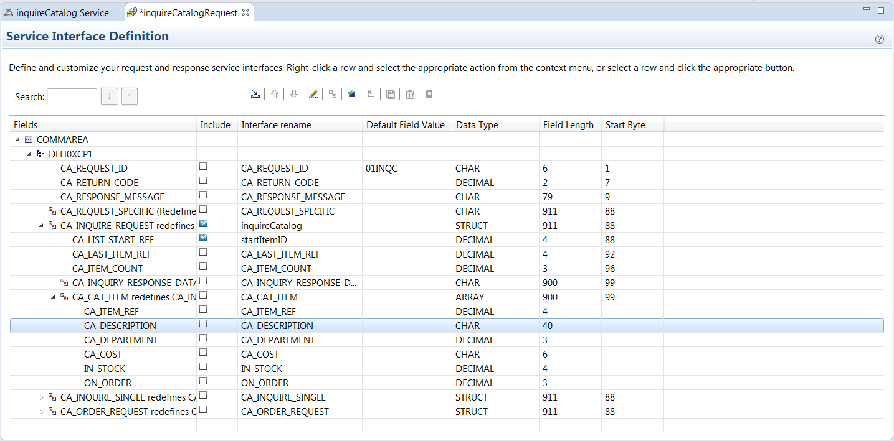

- Close the Service Interface Definition window.
- Repeat steps 6 through 10 to create a service interface for the inquireCatalog response message with the service interface name of inquireCatalogResponse.

- A different set of fields will be returned in the response. Uncheck the boxes under Include column so that only CA_RETURN_CODE, CA_RESPONSE_MESSAGE, CA_INQUIRE_REQUEST, CA_LIST_START_REF, CA_LAST_ITEM_REF, CA_ITEM_COUNT and CA_CAT_ITEM are checked. These are fields that will be exposed to the requestor of this API in the response. Rename these fields if you choose.
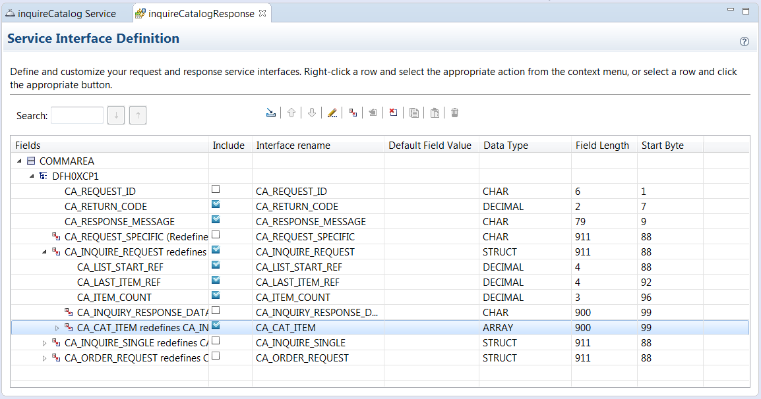

- Close the Service Interface Definition window.
- Set the Response service interface to inquireCatalogResponse.si.
- Identify the connection reference for which CICS region will be used for this service. Click on the Configuration tab at the bottom of the Overview window to display the Configuration window. Enter catalog in the area beside Connection reference.
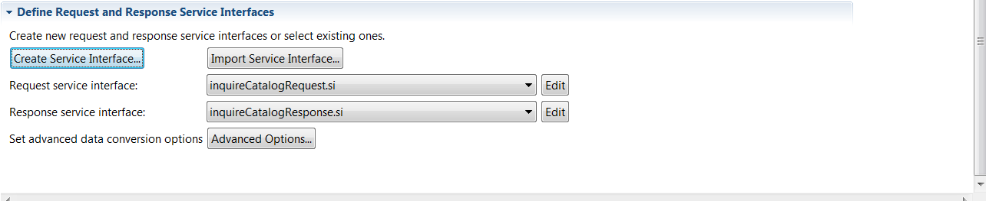
- Verify that the request and response service interfaces are set correctly, if not set them as below.

- Save the inquireCatalog service by closing all open tabs.
- Create a placeOrder service by repeating steps 1 through 5.
- Repeat steps 6 through 10 to create service interface name placeOrderRequest
- Expand the COMMAREA and perform the following steps for the placeOrderRequest:
- First uncheck the boxes under Include column so that only CA_ORDER_REQUEST, CA_ITEM_REF_NUMBER and CA_QUANTITY_REQ are checked. These are the fields that will be exposed to the requestor of this API.
- Double click an entry in the Interface rename column to open it for editing. Rename interface fields CA_ORDER_REQUEST to orderRequest, CA_ITEM_REF_NUMBER to itemID and CQ_QUANTITY_REQ to orderQuantity.
- Change the default value of field CA_REQUEST_ID to a value of 01ORDR.
- Set the default values for CA_USERID to abcdefgh and CA_CHARGE_DEPT to 1234.
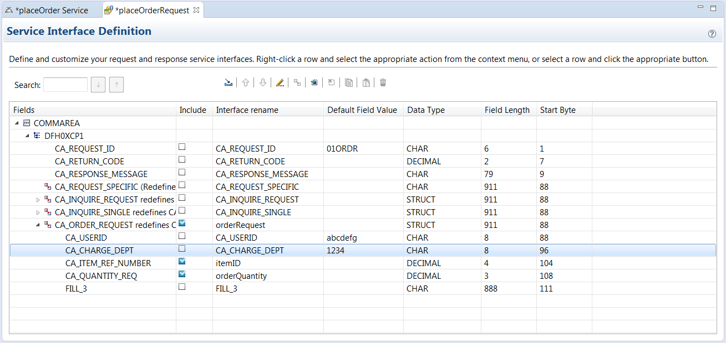
- Close the Service Interface Definition window.
- Repeat steps 6 through 10 to a create service interface placeOrderResponse response message for the placeOrder service.
- A different set of fields will be returned in the response. Uncheck the boxes under Include column so that only CA_RETURN_CODE and CA_RESPONSE_MESSAGE, are checked. These are fields that will be exposed to the requestor of this API in the response. Rename these fields if you choose.
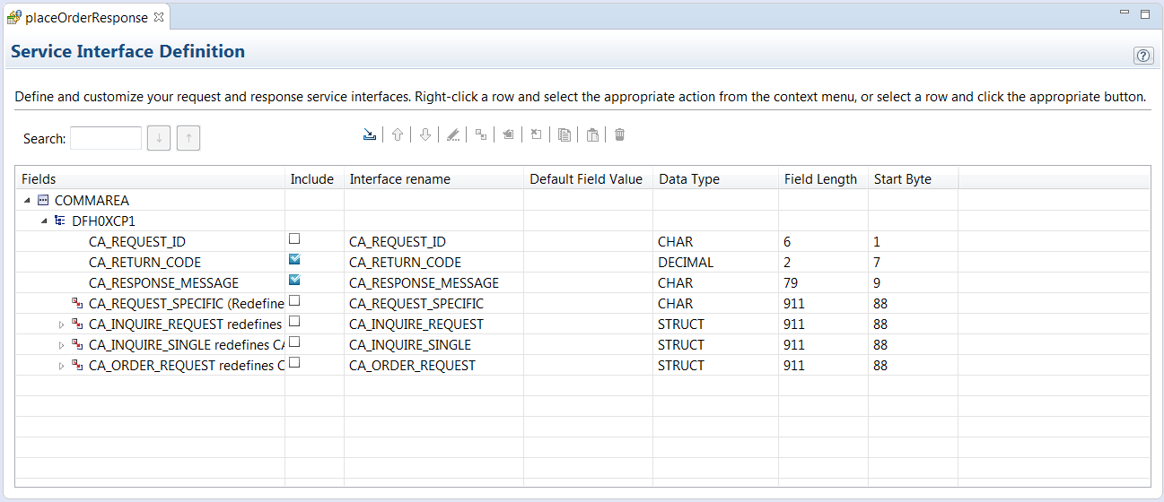
- Set the Response service interface to placeOrderResponse.si.
- Close the Service Interface Definition window.
- Identify the connection reference for which CICS region will be used for this service. Click on the Configuration tab at the bottom of the Overview window to display the Configuration window. Enter catalog in the area beside Connection reference.
- Verify the request and response services interfaces are set correctly, if not set them as below.
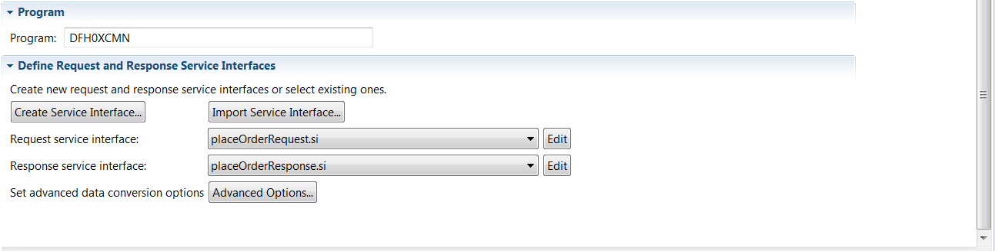

- Save the placeOrder service either by closing all open tabs.

These three services now need to be make available for developing the API and for deployment to the z/OS Connect EE server.

Export and deploy the Service Archive files
Before a service interface can be used it must be exported to create Service Archive (SAR) file and deployed as a SAR file to the server. The exported SAR is used in developing an API in the z/OS Connect EE Toolkit. This section describes the process for exporting and deploying SAR files.
- First ‘export’ them into another project in the z/OS Connect EE Toolkit. Select File on the tool bar and then on the pop up select New → Project. Expand the General folder and select Project to create a target project for exporting the Service Archive (SAR) files. Click Next to continue.
- On the New Project window enter Services as the Project name. Click Finish to continue. This action will add a new project in the Project Explorer named Services.
- Select the inquireCatalog service project and right mouse button click. On the pop-up selection select z/OS Connect EE → Export z/OS Connect EE Service Archive. On the Export Services Package window select the radio button beside Workspace and use the Browse button to select the Services folder. Click OK to continue.
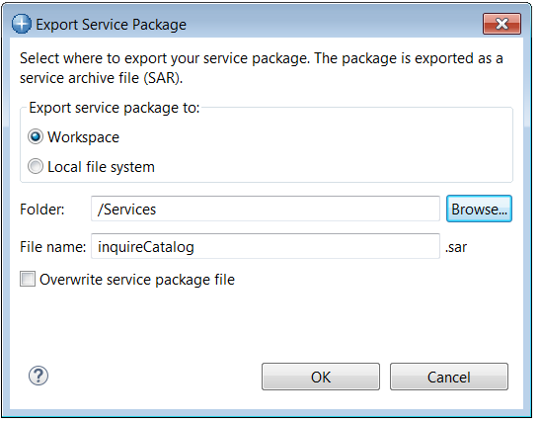

- Select the inquireCatalog service project again and right mouse button click again and on the pop-up selection select z/OS Connect EE → Deploy Service to z/OS Connect EE Server. On the Deploy Service window select the target server (wg31:9453) and click OK twice to continue.
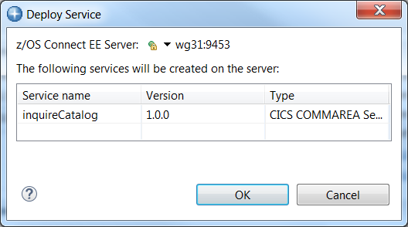

- Repeat these two steps to export the inquireSingle and placeOrder service project to the Services project folder and to deploy the services to the z/OS Connect server.

Create the API Project
- Back in the z/OS Connect EE tool kit create a new project. In the New Project window, scroll down and open the z/OS Connect Enterprise Edition folder and select z/OS Connect EE API Project and then click the Next button.
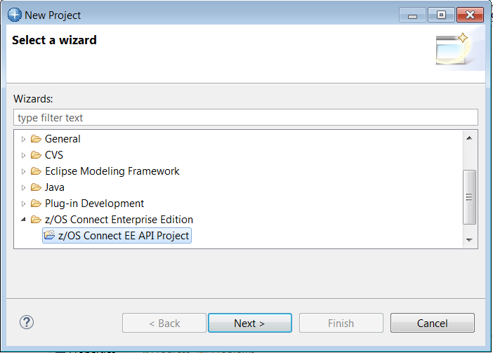

- Enter CatalogManager for the Project name, catalog for the API name and /catalogManager for the Base path value (case is important). Click Finish to continue.
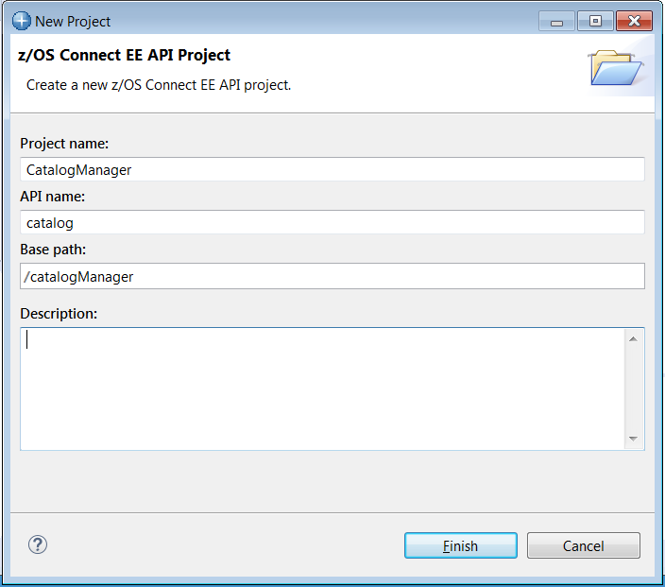

- You should now see something like below. The views may need to be adjusted by dragging the view boundary lines.
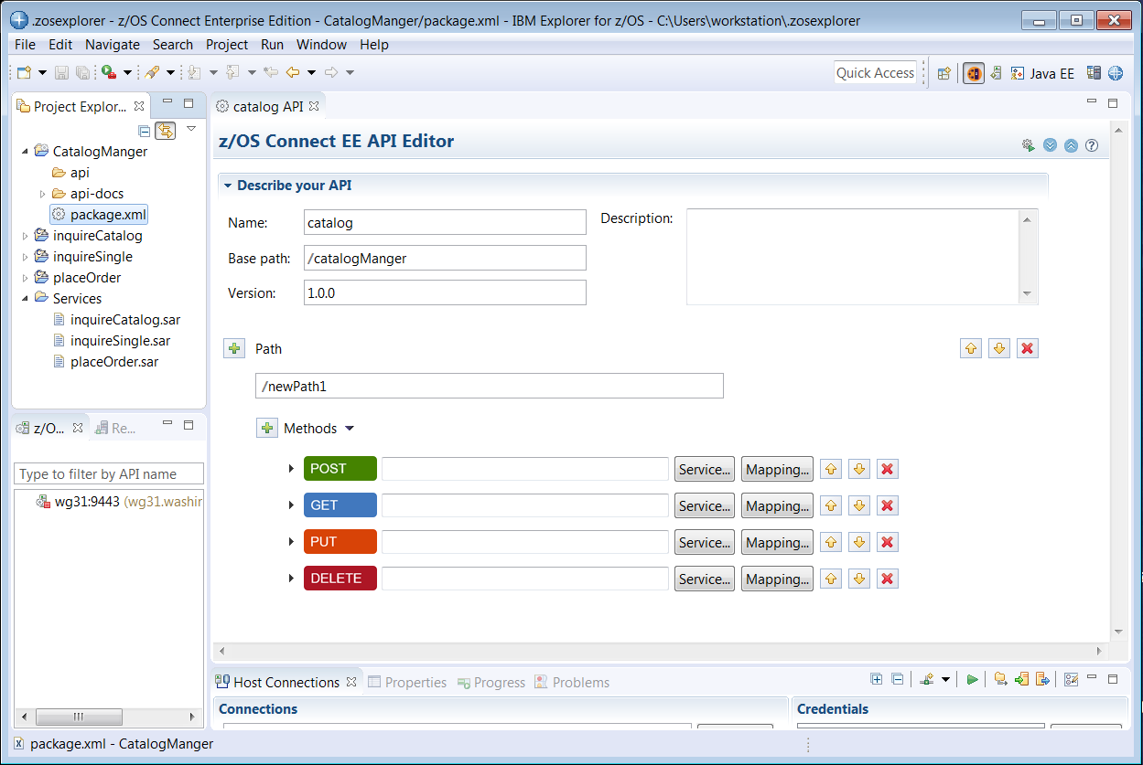

Summary

You created the basic framework for the API project in the API editor.

Compose the API with a CICS COMMAREA application

- To compose the inquireCatalog service start by entering a Path of /items?startItemID.
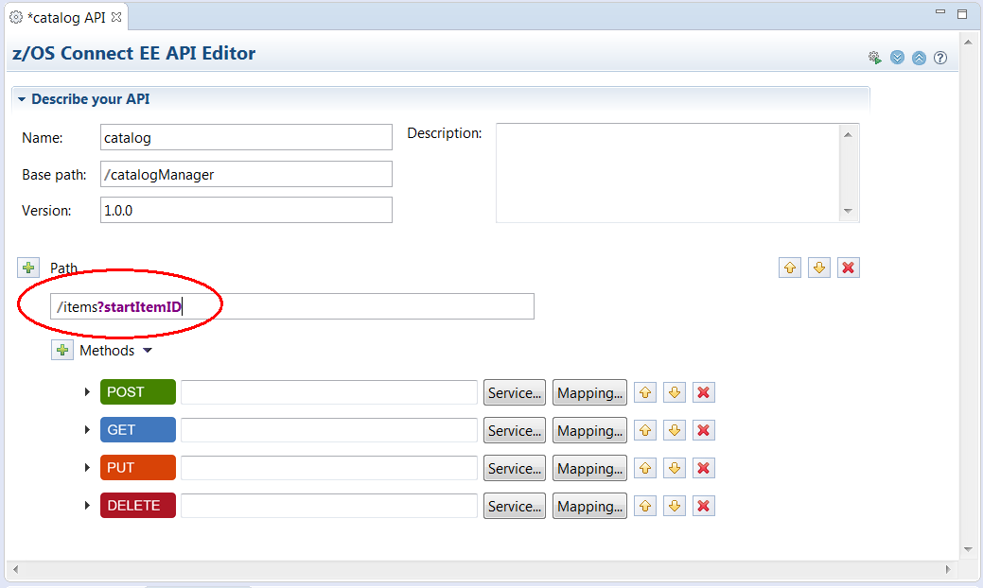

Note: The /items path element is somewhat arbitrary but use this value so tasks later in the exercise will work unchanged.

The ?startItemID element tells the editor that value will be supplied as a path parameter in the URL.

- For the inquireCatalog service the HTTP method will be GET, so we do not need the POST, PUT and DELETE methods. Remove them by clicking the X icon to the right of each:
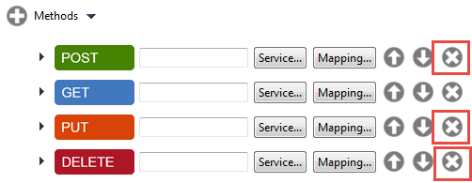

That should leave you with only the GET method.
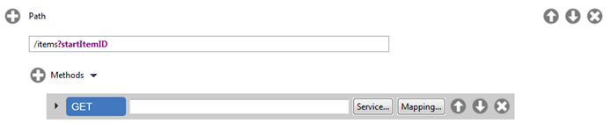

- Next import the service required for this method of this Path. Click on the Service button to the right of the GET method. On the Select a z/OS Connect EE Service window click the Workspace button and expand the Services folder on the next window. Select the inquireCatalog service from the list of service archive files and click OK three times

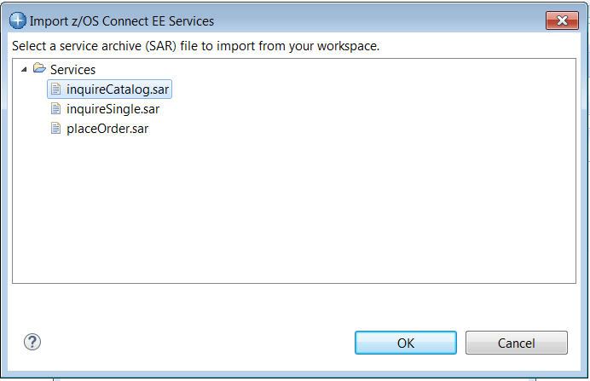

This will populate the field to the right of the method:
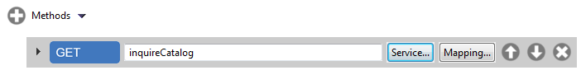

- Save the changes so far by using the key sequence Ctrl-S.
- Next, click on the Mapping button, then select Open Request Mapping:
Tech-Tip: If any change is made in any edit view an asterisk (*) will appear before the name of the artifact in the view tab, e.g. *package.xml. Changes can be saved at any time by using the Ctrl-S key sequence.
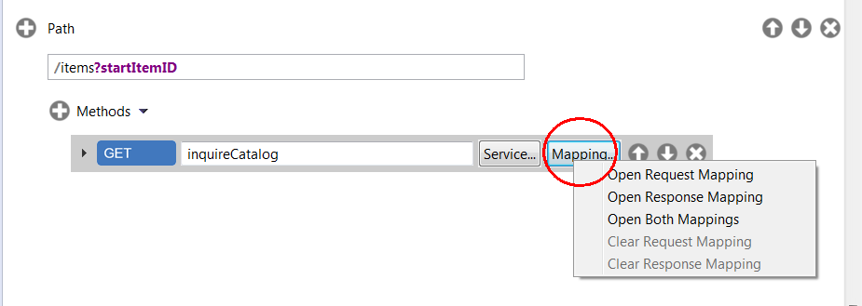

- Expand inquireCatalog on the right and next, on the left side hover select startItemID and without releasing create a connection between startItemID and field startItemID on the right hand side. The result is a line that maps the value of startItemID from the query parameter to the field startItemID. This means the value or contents of startIemID query parameter specified in a URL will be moved to the startItemID field.

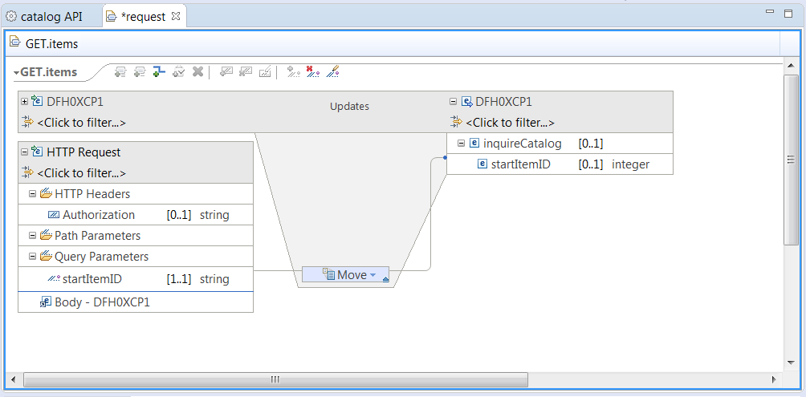

What you have done is reduce the request to a simple GET URI with a single query parameter:

http://<host>:<port>/catalogManager/items?startItemID=10

The query parameter provides the program the starting item number for the listing of items.
Those fields not needed on a request are hidden from the REST client's view. Those fields that have the same static value every time (ca_request_id) are assigned a value of 01INQC.
- Save the changes using key sequence Ctrl-S.
- Close the request mapping tab by clicking on the white X in the tab window.
- No changes are required for the response mapping.

You're done with the inquireCatalog portion of the API. Next up is inquireSingle. The steps are very similar. You will find you get better at this the more you do it.
- Click the plus icon to add another path to the API.
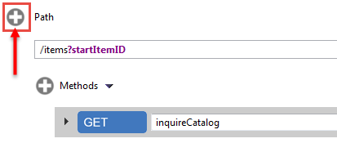

The result is:
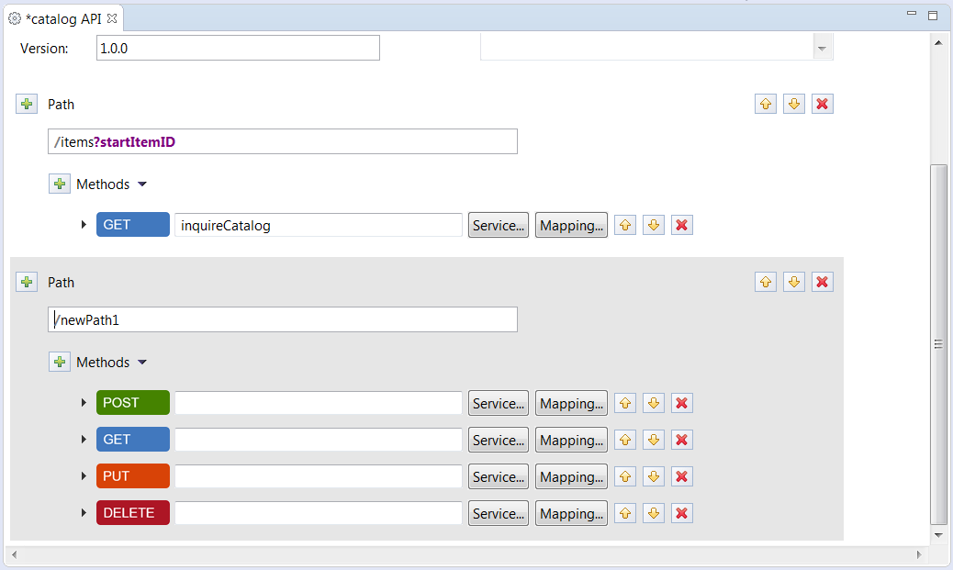
New path for inquireSingle
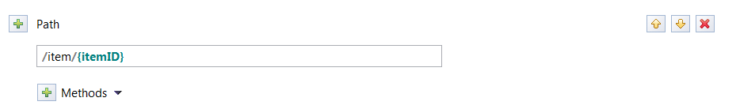
- Enter a path value of of /item/{itemID}:

The string {itemID} is recognized by the editor as a path parameter.

- Once again, the method we will use for this is GET, so we do not need POST, PUT or DELETE. Remove those by clicking the X to the right of each. The result should be:
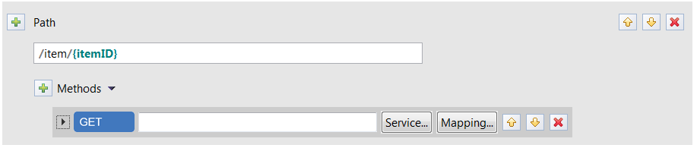

- Next import the service required for this method of this Path. Click on the Service button to the right of the GET method. On the Select a z/OS Connect EE Service window click the Workspace button and expand the Services folder on the next window. Select the inquireSingle service from the list of service archive files and click OK three times.
- Tech-Tip: Additional Paths can be added by clicking the + icon beside Path and additional Methods can be added by clicking the + icon beside Methods.
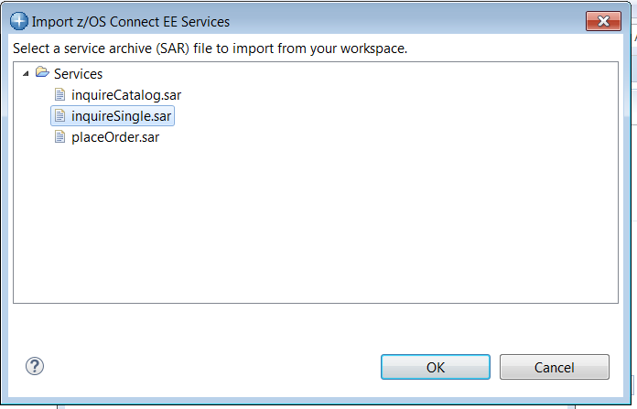

- Save the changes by using the key sequence Ctrl-S.
- Click on Mapping → Open request mapping.
- Expand inquireSingle by clicking on the little + sign to the left of the field. Select itemID on the left-hand side and drag it over to itemID on the right hand side to make a move connection so the value or contents of itemID are moved into itemID field.
- The picture below is the final result. Inspect your mapping and make sure:
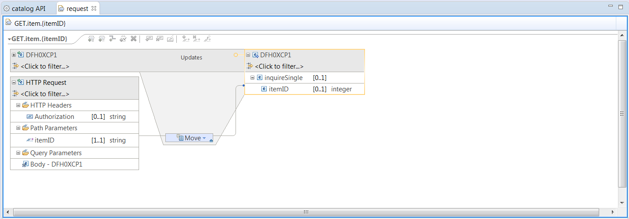
What you have done is reduce the request to a simple GET URI with a single path parameter:

http://<host>:<port>/catalogManager/item/10

The path parameter provides the program the item number for the listing of that item..
- Save the the changes using the key sequence Ctrl-S.
- Close the request mapping tab.
- No changes are required to the response mapping.

One more service to add – orderItem. The process is similar. The steps should be getting familiar to you by this time.

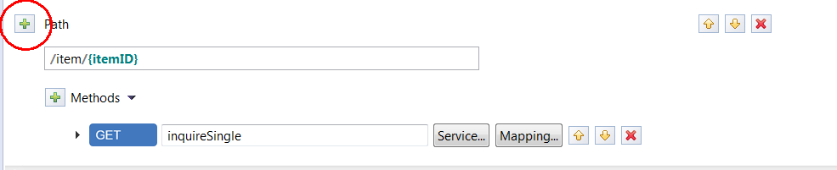
- Add another path by clicking on the + circle:

- In your new path field, provide a path value of /orders:
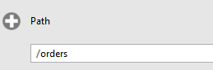

- The HTTP method for this will be POST, so we can get ride of GET, PUT and DELETE. Remove those methods by clicking the X. You should then see:
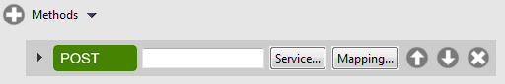

- Click on Mapping → Open request mapping and review. No mappings are required so close the view.

- Import the service required for this method of this Path. Click on the Service button to the right of the GET method. On the Select a z/OS Connect EE Service window click the Workspace button and expand the Services folder on the next window. Select the placeOrder service from the list of service archive files and click OK three times.
- Save the changes by using the key sequence Ctrl-S.

Summary

You created the API, which consists of three paths and the request and response mapping associated with each. That API will now be deployed into z/OS Connect EE V3.0. The REST interfaces are now simpler than the earlier coarse-grained services. The services are still used, but by z/OS Connect EE V3.0 as it processes the higher-level API requests.

Deploy the API to a z/OS Connect EE Server
- The catalog API and inquireCatalog, inquireSingle and placeOrder services were defined by the inclusion of the catalog.xml file in the server.xml.
<server description="CICS Catalog">

<featureManager>
<feature>zosconnect:cicsService-1.0</feature>
</featureManager>

<zosconnect_cicsIpicConnection id="catalog"
host="wg31.washington.ibm.com"
port="1491"/>

</server> "

Figure 1 - catalog.xml

The zosconnect_cicsIpicConnection element provides the CICS IPIC information that will be used for communications with the CICS region,

- In the Project Explorer view (upper left), right-mouse click on the CatalogManager folder, then select z/OS Connect EE→ Deploy API to z/OS Connect EE Server.
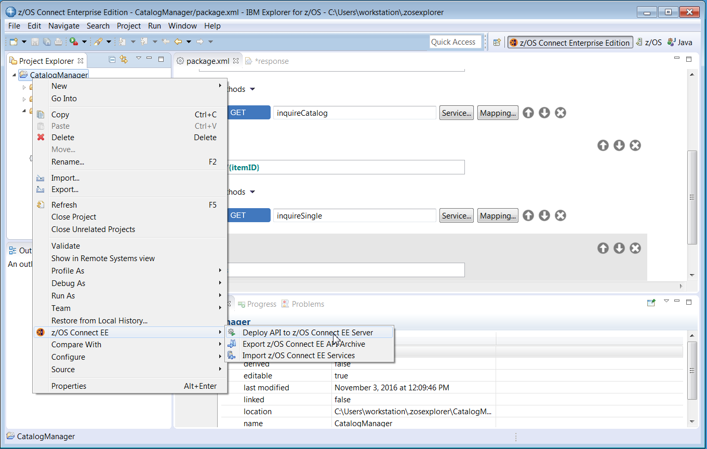

- Since z/OS Explorer is connected to only one z/OS Connect server there is only one choice (wg31:9453). If z/OS Explorer had multiple host connections to z/OS Connect servers then the pull down arrow would allow a selection to which server to deploy. Click OK on this screen to continue.

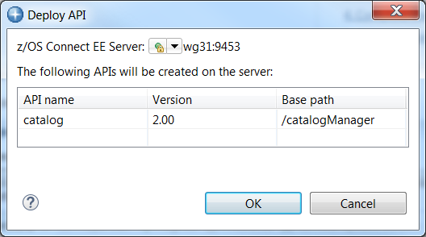

- The API artifacts will be transferred to z/OS and copied into the /var/zosconnect/servers/zceesrv1/resources/zosconnect/apis directory.
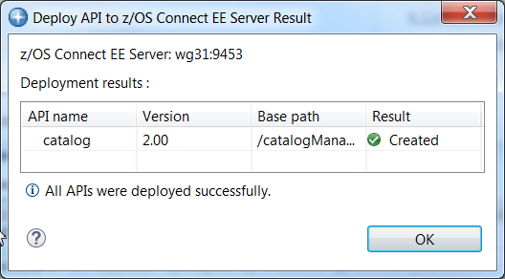

Summary

The API was contained in the AAR file, which you uploaded to z/OS and deployed. The update of the server.xml told z/OS Connect EE V3.0 about the presence of the API.

Test the API
Important: The Swagger UI in the API Toolkit has been configured to use an external browser. This simplifies the management of digital certificates.
- Next enter URL https://wg31.washington.ibm.com:9453/zosConnect/apis in the Firefox browser and you should see the window below. The catalog API now shows as being available.\

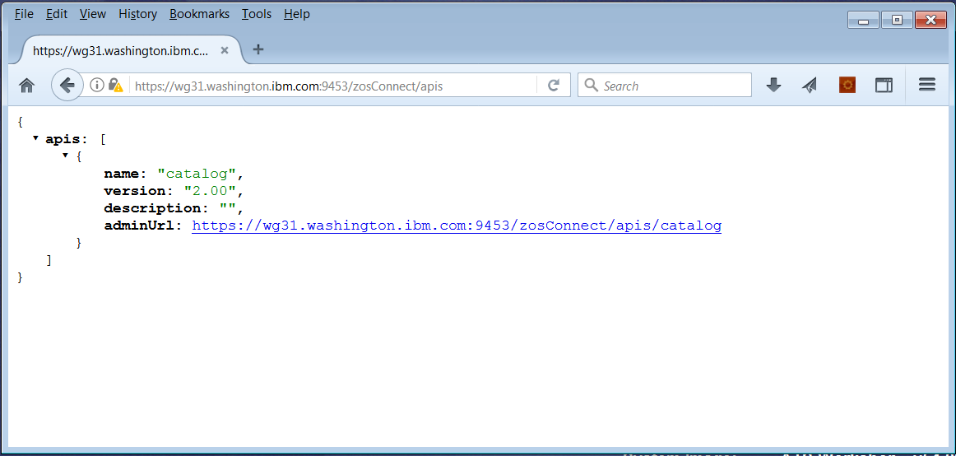

Tech Tip: You may be challenged by Firefox because the digital certificate used by the Liberty z/OS server is self-signed Click the Add Exception button to continue. If the Add Exception button is not displayed click the Advanced button. Then click on the Confirm Security Exception button. Next you may see a prompt you for a userid and password. If you do see the prompt, enter the username Fred and password fredpwd (case matters) and click OK. Remember we are using basic security and this is the user identity and password defined in the server.xml file.
Tech Tip: It is very important to access the z/OS Connect server from a browser prior to any testing using the Swagger UI. Accessing a z/OS Connect URL from a browser starts an SSL handshake between the browser and the server. If this handshake has not performed prior to performing any test the test will fail with no message in the browser and no explanation. Ensuring this handshake has been performed is why you may be directed to access a z/OS Connect URL prior to using the Swagger UI during this exercise.
- If you click on adminUrl URL the window below should be displayed:
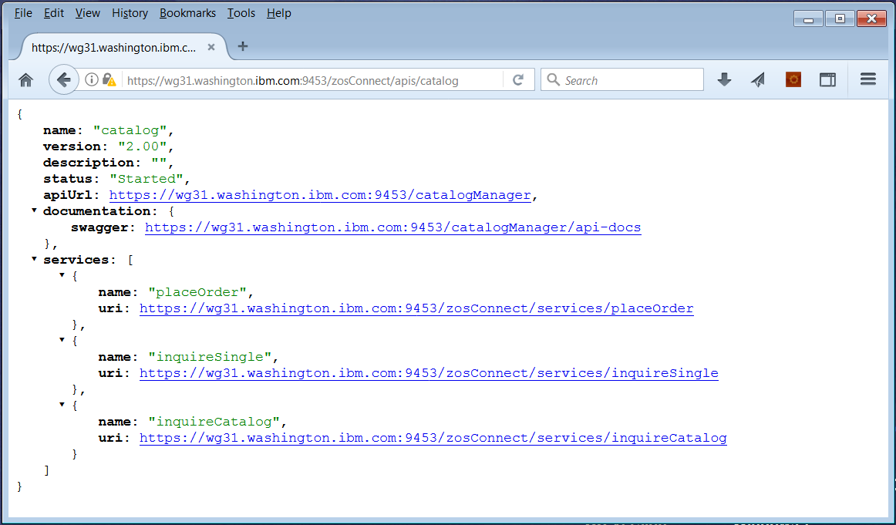

- Next click on the swagger URL and you should see the Swagger document associated with this API.
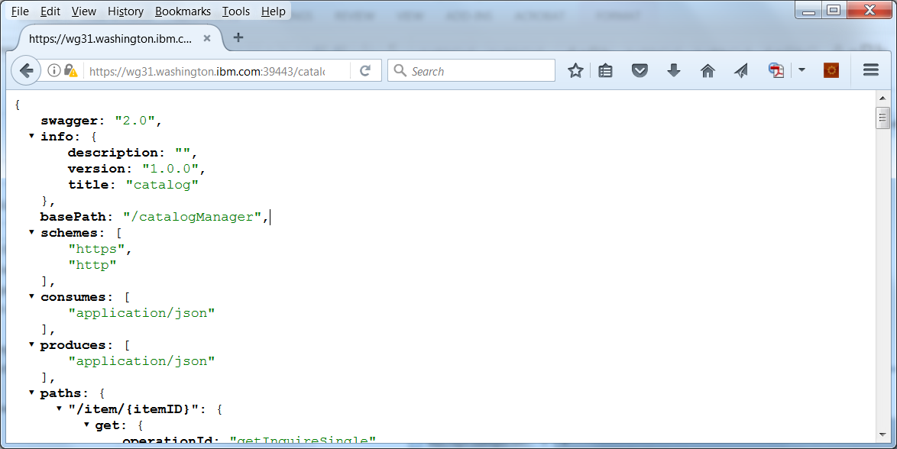

Explore this Swagger document and you will see the results of the request and response mapping performed earlier. This Swagger document can be used by a developer or other tooling to develop REST clients for this specific API.
- In the lower left-hand side of the z/OS Connect Explorer perspective there is view entitled z/OS Connect EE Servers. Expand wg31:9453 and the expand the APIs folder. You should see a list of the APIs installed in the server.
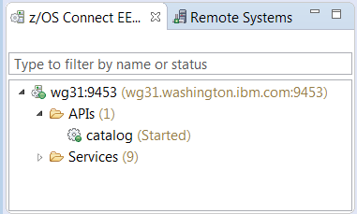

- Right mouse button click on catalog and select Open in Swagger UI. Click OK if an informational prompt about certificates appears (see Tech Tip for explanation). This will open a new view showing a Swagger test client (see below).
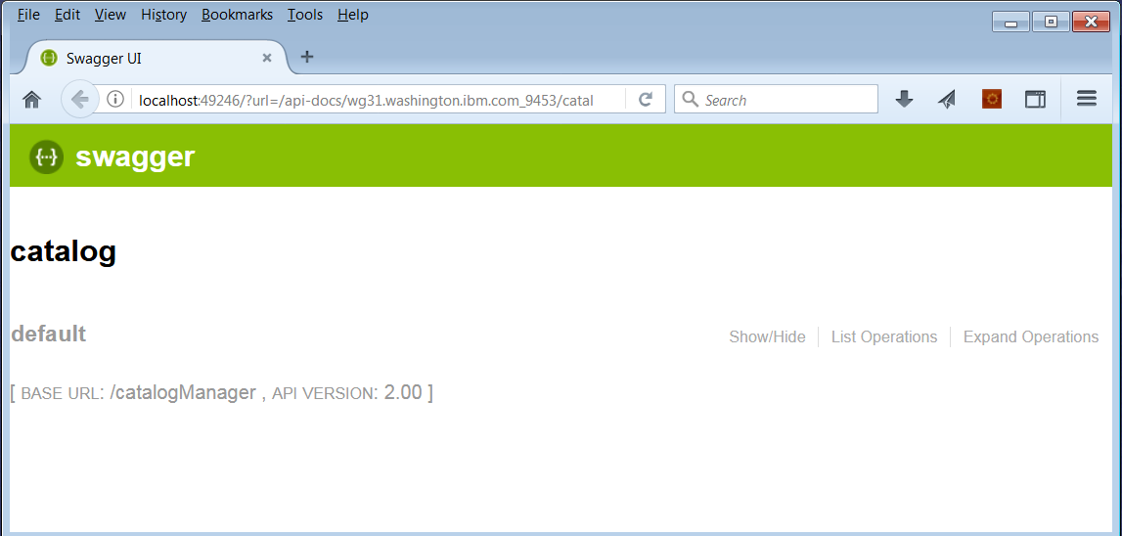

Tech Tip: Swagger UI will not try to automatically download the self-signed certificate from the z/OS Connect EE server. The server’s self-signed certificate must be install using other means. In this exercise, the self-signed certificate was installed earlier when displaying the APIs or services installed in the z/OS Connect EE server. Note that this must be done for every server that will be accessed using the Swagger UI.

- Click on List Operations option in this view and this will display a list of available HTTP methods in this API.
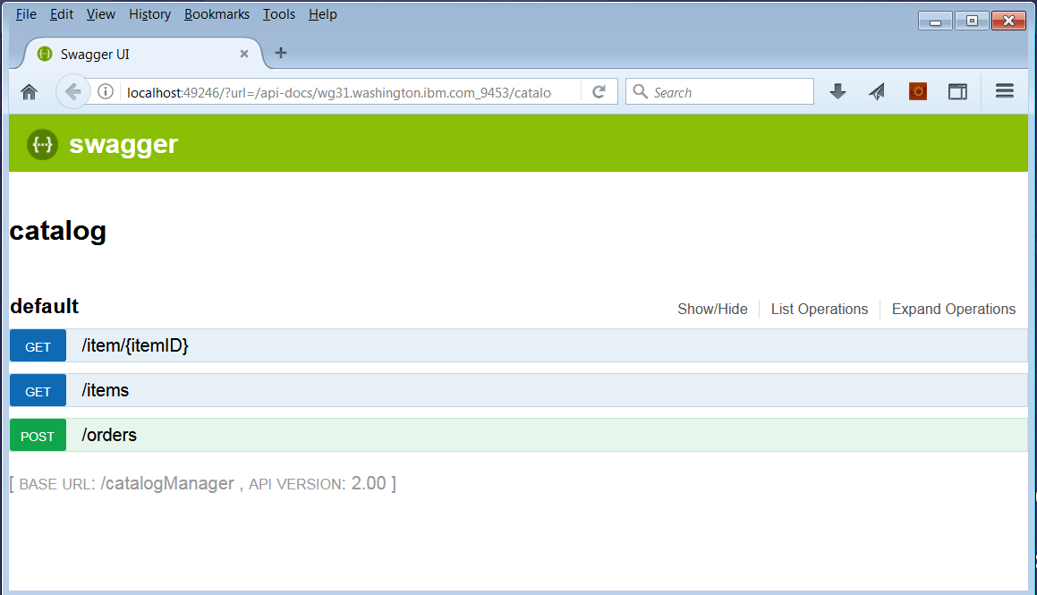

- Select the method for selecting a single item from the catalog by item number table by clicking on the GET box. This action will expand this method in this view and provides a Swagger UI test client (you may have to use the slider bar and adjust the perspective to see the entire client).
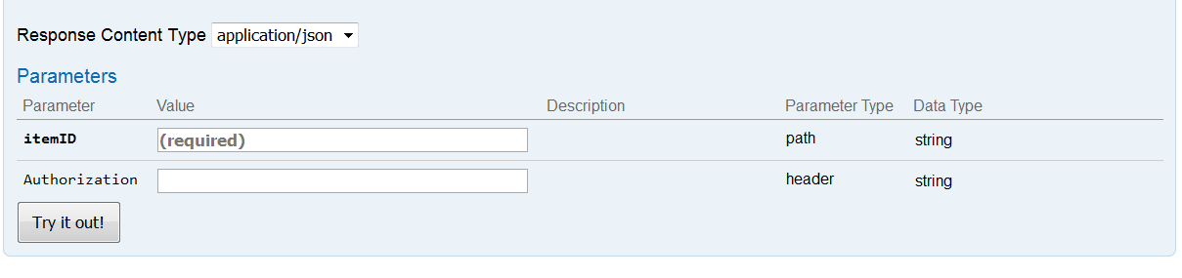
- Enter 10 in the box beside itemID and Basic RnJlZDpmcmVkcHdk in the area beside Authorization and press the Try it out! button. You may see a Security Alert pop-up warning about the self-signed certificate being used by the z/OS Connect EE server. Click Yes on this pop-up.
Tech Tip: Since the z/OS Connect EE server require security the Swagger UI must include the authorization string in the Request Header. The format of this authorization string is the type of authorization (e.g. Basic) and the base 64 encoded string for Fred:fredpwd ,e.g RnJlZDpmcmVkcHdk, see URL https://www.base64encode.org. and/or the z/OS Connect EE V3 Getting Started Guide, TechDoc WP102724. Be sure there are no extra spaces at the end of the string.

- Scroll down the view and you should see the Response Body which contains the results of the GET method (see below). Note that the request field removed from the interface in an earlier steps is not present.
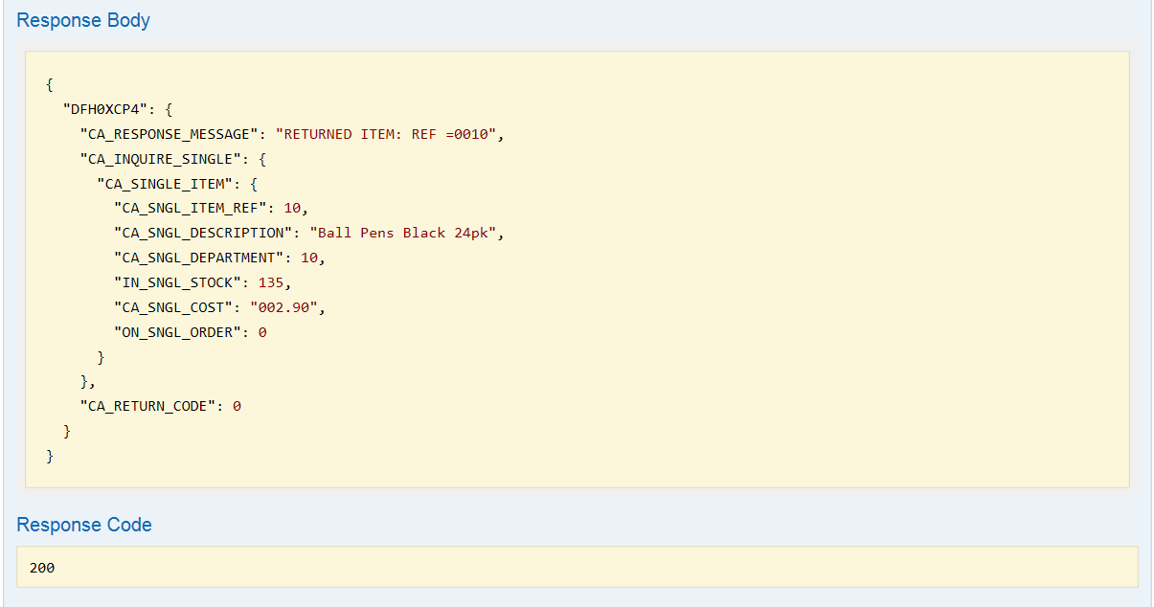
- Repeat this process with other items and observe the results. For example using a value of 30 would return.
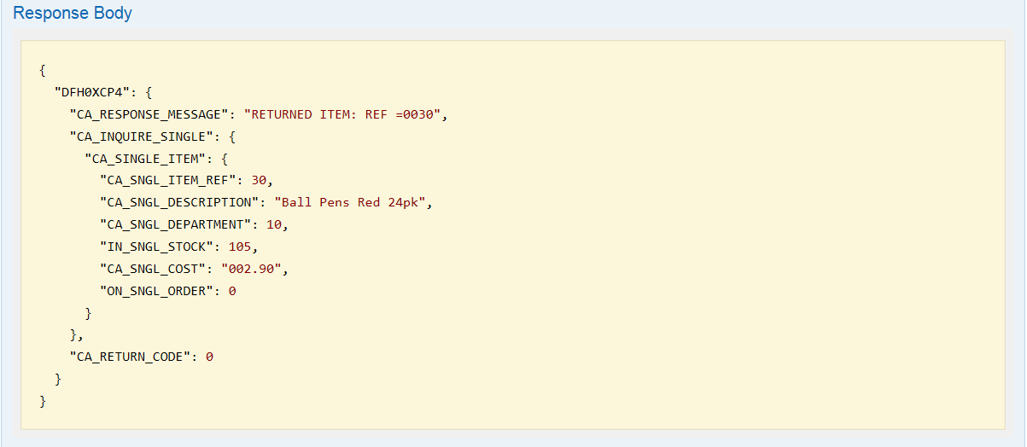

The available catalog items are listed below.

Item# | Description | Dept | Cost | In Stock | On Order
0010 | Ball Pens Black 24pk | 010 | 002.90 | 0135 | 000
0020 | Ball Pens Blue 24pk | 010 | 002.90 | 0006 | 050
0030 | Ball Pens Red 24pk | 010 | 002.90 | 0106 | 000
0040 | Ball Pens Green 24pk | 010 | 002.90 | 0080 | 000
0050 | Pencil with eraser 12pk | 010 | 001.78 | 0083 | 000
0060 | Highlighters Assorted 5pk | 010 | 003.89 | 0013 | 040
0070 | Laser Paper 28-lb 108 Bright 500/ream | 010 | 007.44 | 0102 | 020
0080 | Laser Paper 28-lb 108 Bright 2500/case | 010 | 033.54 | 0025 | 000
0090 | Blue Laser Paper 20lb 500/ream | 010 | 005.35 | 0022 | 000
0100 | Green Laser Paper 20lb 500/ream | 010 | 005.35 | 0003 | 020
0110 | IBM Network Printer 24 - Toner cart | 010 | 169.56 | 0012 | 000
0120 | Standard Diary: Week to view 8 1/4x5 3/4 | 010 | 025.99 | 0007 | 000
0130 | Wall Planner: Erasable 36x24 | 010 | 018.85 | 0003 | 000
0140 | 70 Sheet Hard Back wire bound notepad | 010 | 005.89 | 0084 | 000
0150 | Sticky Notes 3x3 Assorted Colors 5pk | 010 | 005.35 | 0036 | 045
0160 | Sticky Notes 3x3 Assorted Colors 10pk | 010 | 009.75 | 0067 | 030
0170 | Sticky Notes 3x6 Assorted Colors 5pk | 010 | 007.55 | 0064 | 030
0180 | Highlighters Yellow 5pk | 010 | 003.49 | 0088 | 010
0190 | Highlighters Blue 5pk | 010 | 003.49 | 0076 | 020
0200 | 12 inch clear rule 5pk | 010 | 002.12 | 0014 | 010
0210 | Clear sticky tape 5pk | 010 | 004.27 | 0073 | 000

- Collapse the Swagger UI test area for the GET single item method for the clicking on the blue GET box beside /item/{itemID}.

- Click on the blue GET box beside /items to access the GET method to open its Swagger Test user interface for the inquire catalog service (e.g. inquireCatalog) and scroll down to the Response Content Type area.
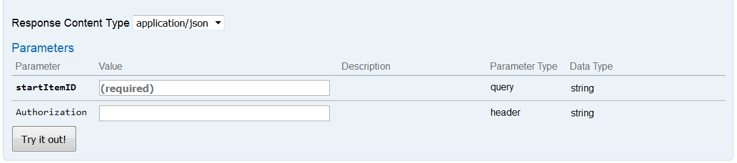

- Enter 40 in the box beside startItemID and Basic RnJlZDpmcmVkcHdk in the area beside Authorization and press the Try it out! button. Scroll down and you should see the following information in the Response Body.

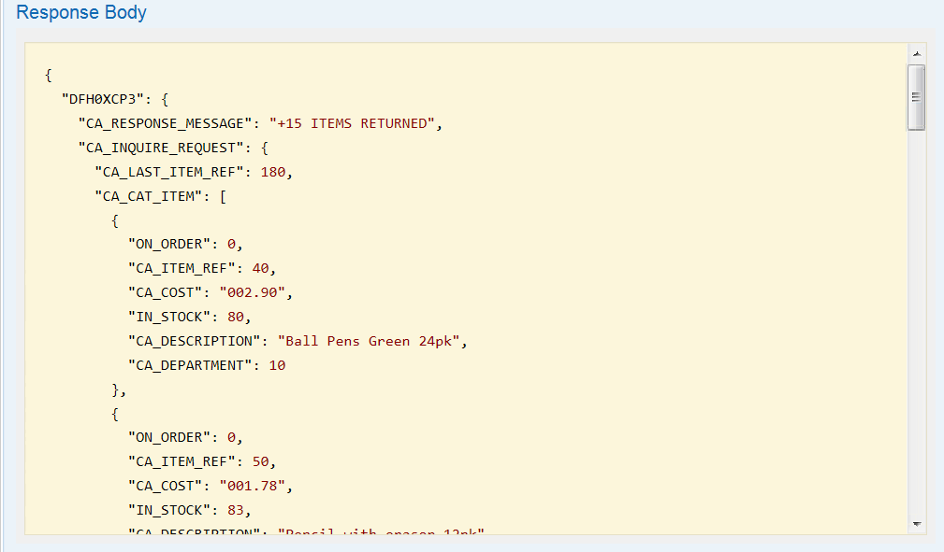

Try a few other values for startItemID and compare the resultse.

- Click on the green POST box to access the POST method to open its Swagger Test user interface for the place order service (e.g. placeOrder) and scroll down to the Response Content Type area.

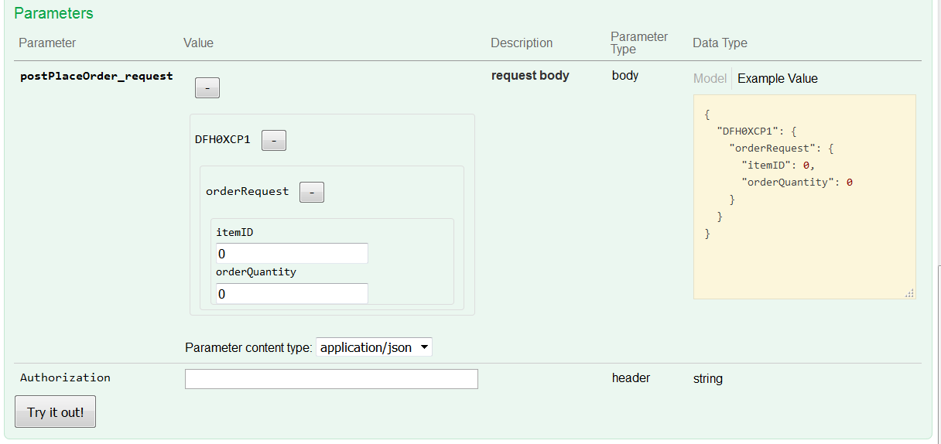
- Enter 40 in the area below itemID and 1 in the area under orderQuantity and Basic RnJlZDpmcmVkcHdk in the area beside Authorization and press the Try it out! button

Scroll down and you should see the following information in the Response Body.
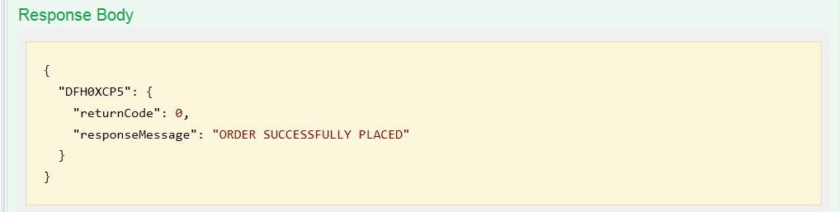

Summary

You have verified the API. The API layer operates above the service layer you defined and tested earlier. The API layer provides a further level of abstraction and allows a more flexible use of HTTP verbs, and better mapping of data via the API editor function.

Optional
Start a 3270 session with CICS and enter CICS transaction CEDX CSMI. When you repeat of any of the above test you should be able to trace the flow of the request through CICS.

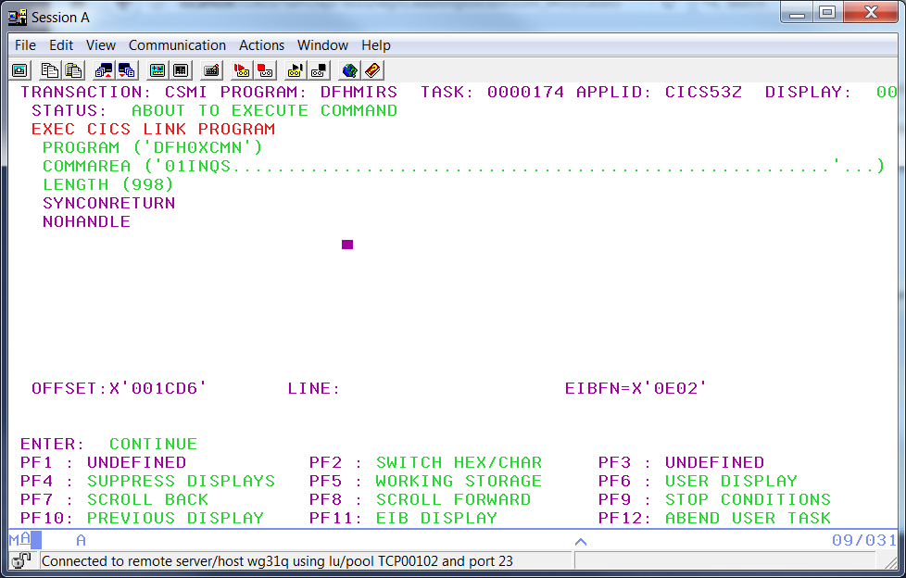

Summary
You have verified the API. The API layer operates above the service layer you defined. The API layer provides a further level of abstraction and allows a more flexible use of HTTP verbs, and better mapping of data via the API editor function.

